**Final Assignment Electronic Instrumentation- Colorimeter**

**Report written by Shraddha Raghuram, Partner: Victor Post**

**Electronics:**

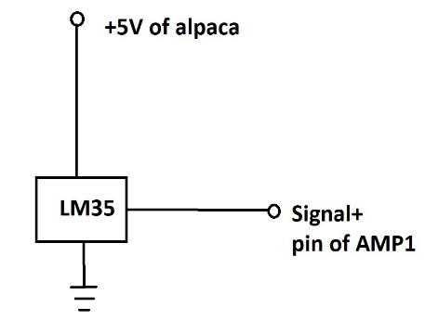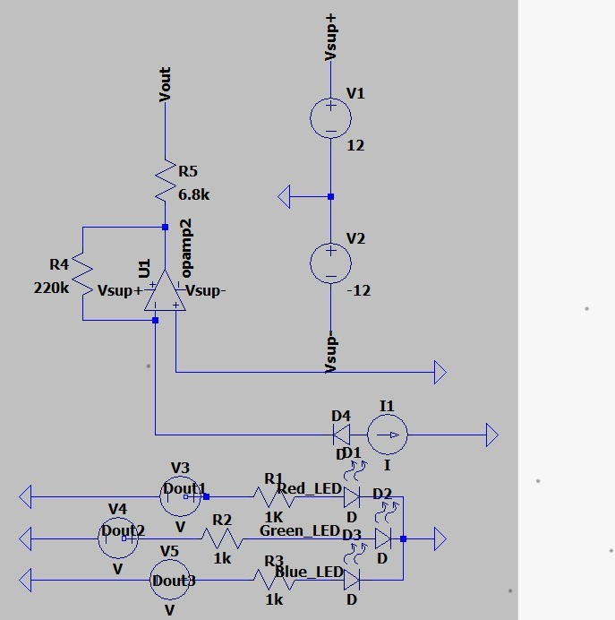

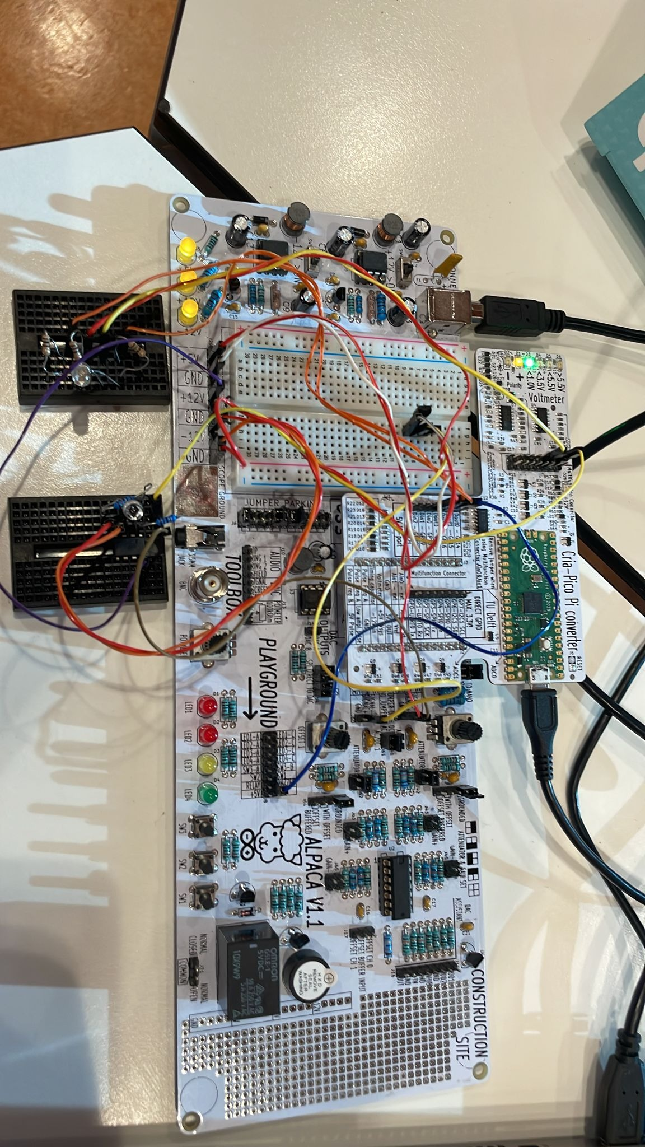

The circuit made by us is that of a colorimeter. We made a separate circuit for the LED and a separate circuit for the photodiode. When an LED conducts current, they emit light. Each color of the LED has a common cathode, and different anodes, these anodes are the pins that are plugged into different slots into the breadboard. As seen from the circuit, as well as the picture, different resistors are connected in series, to each pin of the LED. These resistors serve the purpose of limiting the current. The absolute maximum current of the LED, is 30 mA. We need to get a current well below this value for safety reasons. So we pick a current of 20 mA. We get the forward voltage of the LED for each color from the data sheet, and calculate the values of the series resistances as follows.

For RED:

Vf= 1.9 V

U(R1)= Usupply-U(LED)= 5-1.9=3.1 V

Using Ohm’s law,

R1= U(R1)/I=3.1V/20mA=155 Ohm

I used a 150 Ohm resistor.

For GREEN:

Vf=3.2 V

U(R2)= Usupply-U(LED)=5-3.2=1.8 V

Using Ohm’s law,

R2=U(R2)/I=1.8V/20mA=95 Ohm

I used a 100 Ohm resistor.

For BLUE:

Vf=3.3 V

U(R3)=Usupply-U(LED)=5-3.3=1.7V

R3=U(R3)/I=1.7V/20 mA=85 Ohm

I used a 100 Ohm resistor.

The photodiode then senses the light emitted from the LED and produces a current. This current is converted into a voltage with the help of the opamp circuit which works as a current to voltage current. In this circuit, the 220k resistor was used to amplify the signal from the LED, and the 4.7k resistor was used to limit the voltage measured at Vout. This voltage, when directly measured is too small to give us a nice graph. At first the signal was of a decent order of magnitude for red light. However for green and blue light it was of the order of 10^-6 V, which was too small. So I applied an amplification to my signal. This was implemented by connecting the Vout to signal+ on my ALPACA. The jumper settings of gain+ and gain- were in the 10x setting, as this produced the most reasonable result. The final amplified voltage is thus obtained at Vout which is the signal that we measure. The signal at first was quite noisy. To minimize this noise, I wound some of the signal cables with a neighbouring cable that was grounded. This reduces the noise produced by the magnetic field of the wire. I also implemented a ‘dark box’ as can be seen from pictures that follow. This reduced any background noise from surrounding light sources apart from the LED, which could produce unwanted current in the photodiode.

**Jupyter:**

I will attach the notebook to this submission. However, I am also explaining my code in this report, as it may not be completely legible from my notebook.

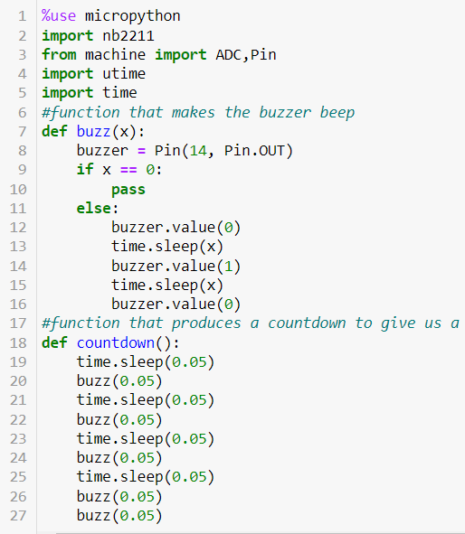

In this piece of code, I first implement a function for making the buzzer beep without too many lines of code. This was the buzz(x) function. The countdown() function was basically created by us as we had initially planned on doing an iteration of the RGB test in a for loop that repeats 4 times. For each iteration we measure a different solution, and at the end of the measurement we start the countdown which warns us that the measurement is done, and tells us to quickly swap the cuvette in the setup, to start the next measurement in time. This worked well for us the first time we ran it. However, the second time we ran it we came across a memory allocation error which we tried our best to resolve , but couldn’t. Hence, we just used this countdown function as a way of producing a nice sequential buzzing sound when the LED switches colors.

Next, I started the test.

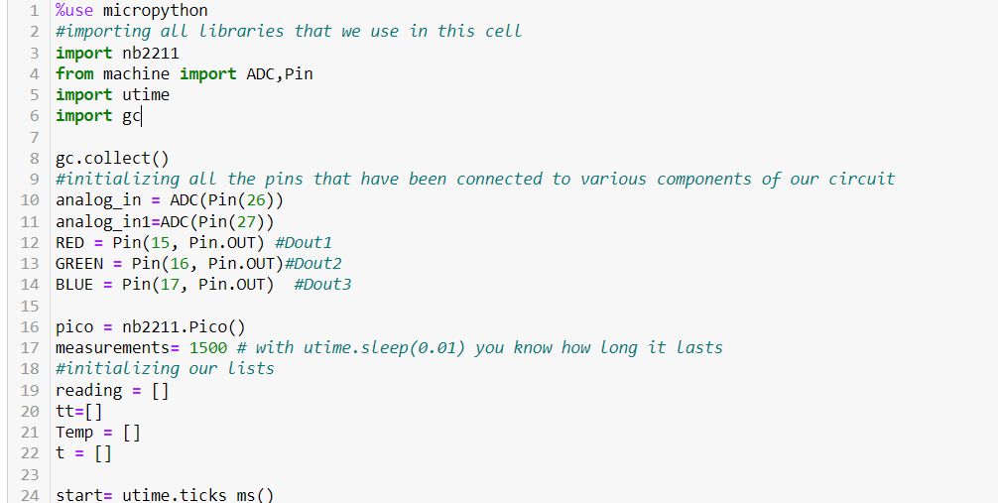

We then have a for loop that switches on different colors of the LED based on the measurement number. Due to memory allocation problems we took very few data points, which is explained in the comments. We were also not able to store this data in our ALPACA due to the same reason. Thus, we decided to rerun the code without an iteration for each measurement, and store the data in separate lists using python, and not micropython. I explained this in the comments as well. Similarly, we measure the temperature and the time using the code I will show below. However these measurements are commented out as we rerun the code, to avoid unnecessary and repeated reproduction of data.

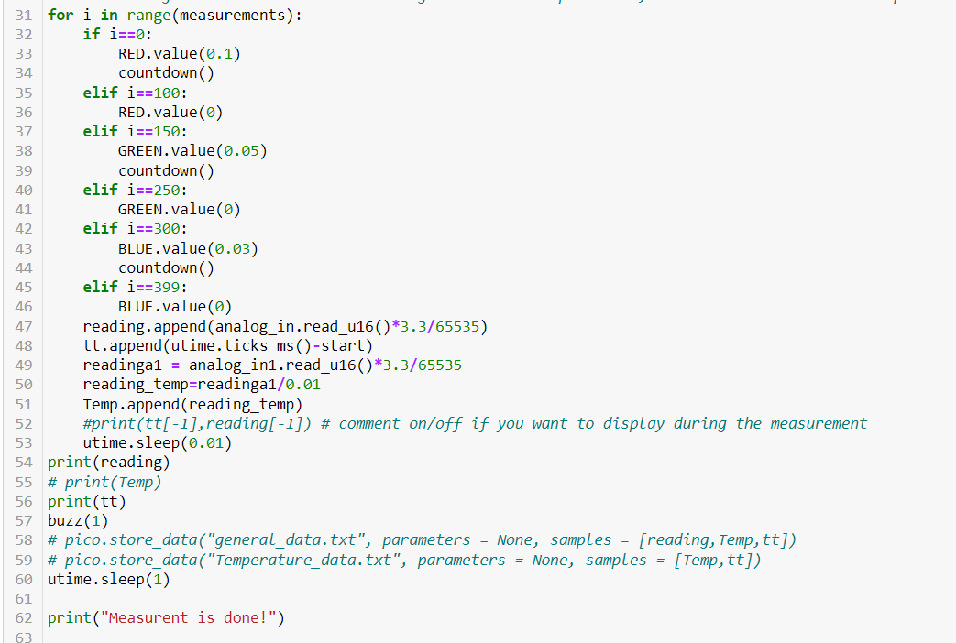

The four different cuvette readings we took were:

1. Cuvette with water-readings1
2. Cuvette with 1.25 microM of dye-readings2
3. Cuvette with 2.5 microM of dye-readings3
4. Cuvette with 5 microM of dye-readings4

We then created 3 different lists and called them Absorbance_red, Absorbance_green and Absorbance_blue. Each element of each of these lists contained the mean of the readings of each separate cuvette with the respective light. Although, the name of these lists is Absorbance, I am aware that what is measured here is just the intensity and not yet the absorbance. This brings us to the next part of the code.

This part has been changed in the notebook, as I forgot to add a new cell to measure the data for the biochemical reaction, and accidentally just changed them in the notebook. However, I had still saved the code, and output outside the notebook.

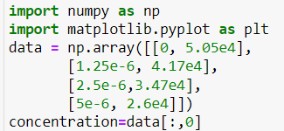

Here, the first column shows the concentrations of the different cuvettes.

The explanation for the code below is in the paragraphs above.

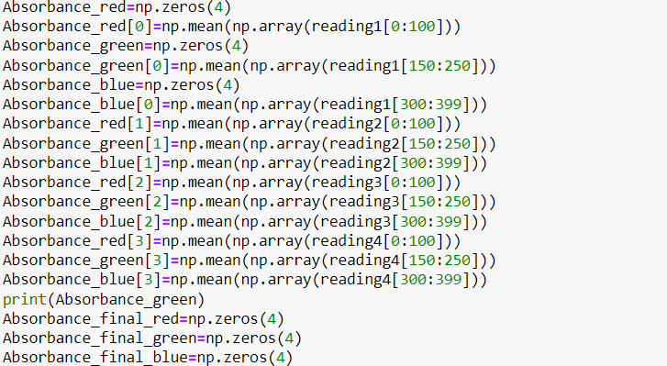

The next piece of code now uses the formula for Absorbance which is log(Intensity of light in water/Intensity of light measured in the given solution).

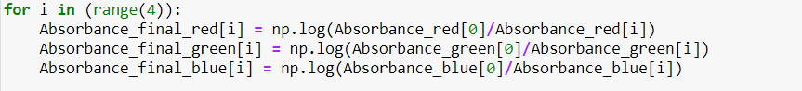

Finally, we plot the data using the code below.

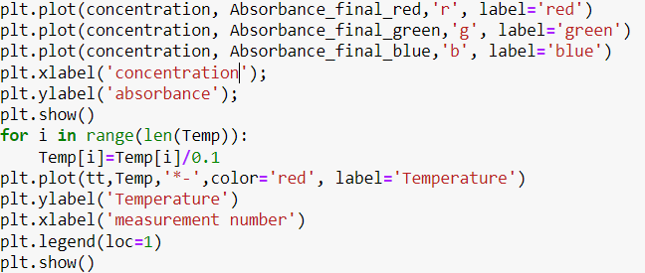

We then measure the molar extinction coefficient using the code below.

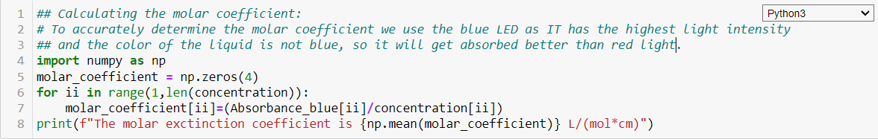

The movie of the RGB LED test will be attached with my submission.

The graph of the basic photodiode test is as given below.

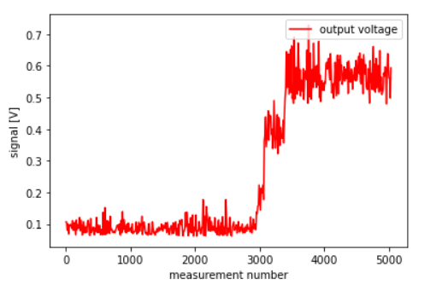

Since, I did different parts of the assignments on different days, the signal I obtained on different days were different as on some days due to defects in my circuit/code, I had to accordingly either rebuild parts of my circuit, or rewrite parts of my code.

**Light Enclosure:**

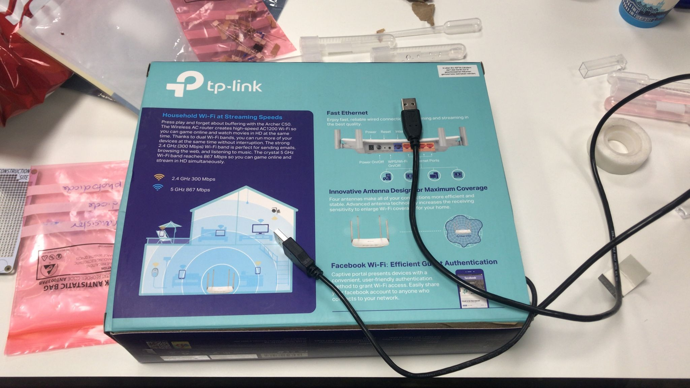

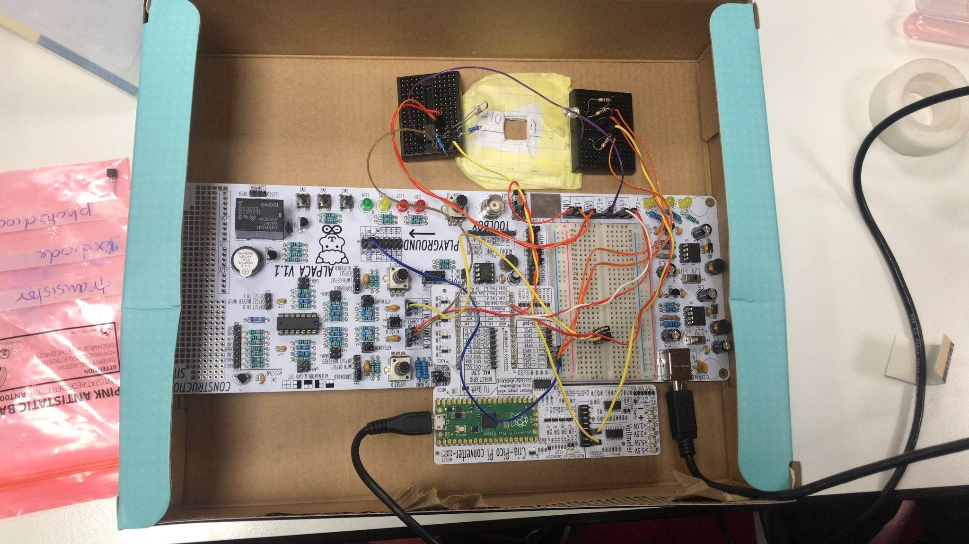

With box open:

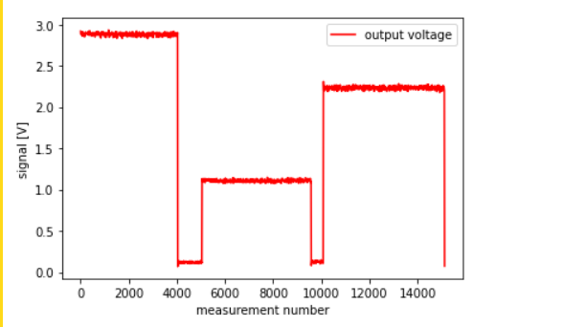

With box closed:

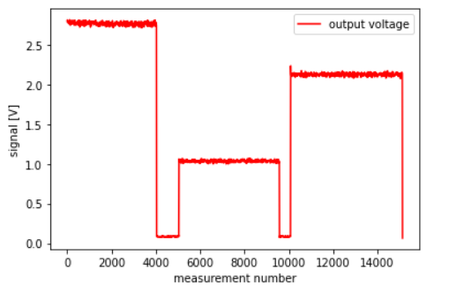

**Color dye:**

Absorbance Vs Concentration plot:

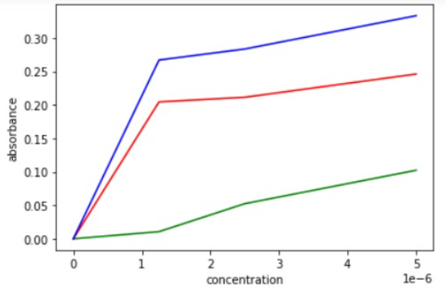

This plot makes sense as the absorbance indeed increases with increase in concentration. This happens because with increase in concentration, the colour of the solution becomes darker and darker, making it more and more opaque and thus increasing its ability to absorb the light emitted from the diode.

The molar extinction coefficient is 99000.0 L/(mol*cm).

**Implementation of a transistor:**

Our implementation of a transistor is as a temperature sensor. We use this to show that heating up of the resistors in the circuit, does not cause any drastic temperature change in the circuit. In case we need to make any modifications required to the circuit, we know that it is safe to touch it as the temperature of the circuit at the end of the measurement is the same as at the beginning.

The graph below shows that temperature does not change drastically. However, it gives the odd values of temperatures in 75’s-80’s. We came to the conclusion that this might be due to the fact that the temperature that might be measured could be in Fahrenheit and not in Celsius.

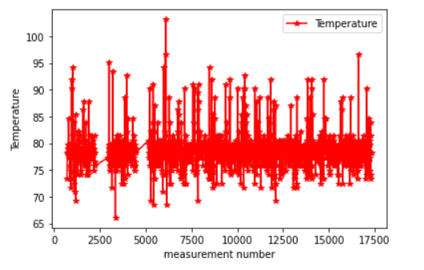

**Optimalization:**

**Biochemical Reaction:**

We use the biochemical reaction of the red cabbage indicator. Red Cabbage has the chemical anthocyanin which functions as a pH indicator of acids, bases and neutral chemicals. The color scheme of various pH is as follows:

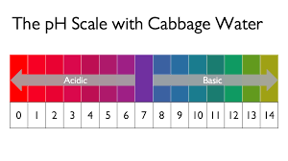

Figure: The pH Scale with Cabbage Water: <https://themuseum.ca/wp-content/uploads/2020/04/For-Site-Colour-Changing-Cabbage-Water.pdf> (Page 1)

We used vinegar, which is acetic acid, water and baking soda, which is sodium bicarbonate.

We added these to the indicator solutions and got the colors below. Using this, we found the pH as follows:

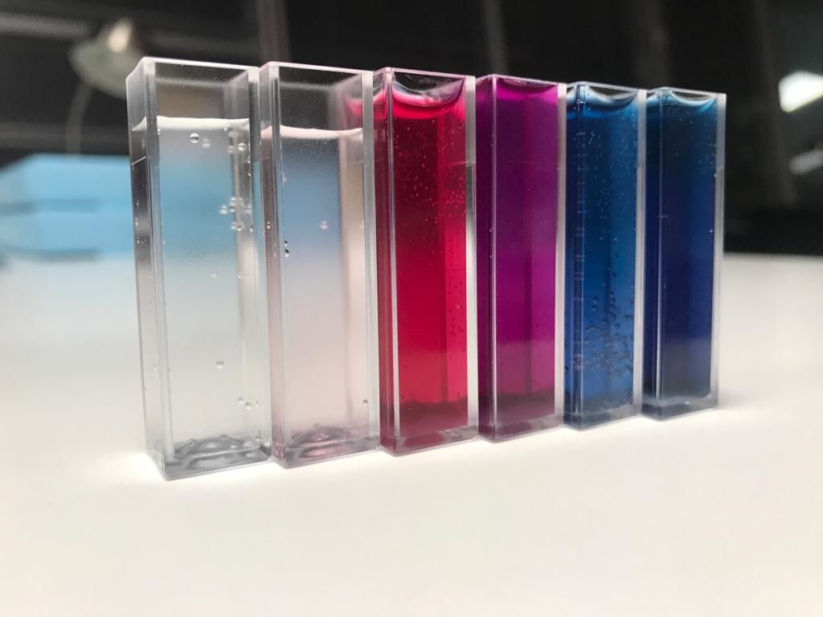

Acetic acid; pH 3, Tap water; pH 6, small amount of baking soda in water; pH 8, large amount of baking soda in water; pH 9

We then took the readings similarly as we did for the dye. Except, this time readings1 were the readings for acetic acid, readings2 were the readings for water, readings3 were the readings for a small amount of baking soda in water, readings4 were the readings for a large amount of baking soda in water. The means and plots were calculated in exactly the same way, and the code is still visible in the notebook. However, for the absorbances, instead of taking the each element in the absorbance lists as log(absorbance[0]/absorbance[i]), we took log(max(absorbance)/absorbance[i]). We did this to avoid getting a negative absorbance as we are no more plotting absorbance with concentration, but plotting it with pH.

We then got the plot as follows:

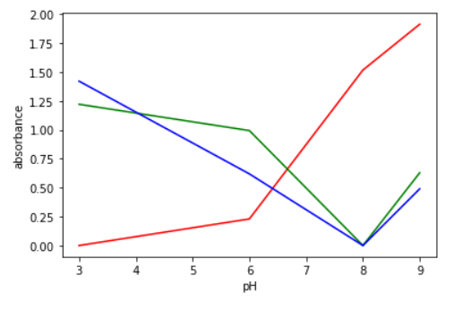

This plot makes sense as now, we are plotting absorbance against pH and not concentration. So for approximately neutral pH’s the absorbance is very low. However, for acidic and basic pH’s it is higher. We can see that from the plot the graphs are different for red light vis-à-vis blue and green lights. This is because in acidic pH’s the solution turns red according to the chart, and so the absorbance is very low, and higher on the basic end. However, the opposite happens for green and blue light. The small increase in absorbance from pH 8 to pH 9 can be explained by the fact that the color transition becomes bluish-green. This probably causes the different colors in the solution to absorb the other color from the light.

**Electronics implementation:**

For the additional implementation, we implemented a buzzer which beeps when the measurement is done as well as works as a countdown. Due to technical issues with memory allocations, we had to change the use of this code which was earlier working for the purpose it was supposed to serve, but not anymore. Our original plan included making an iteration that repeats the RGB switching 4 times, and after each iteration starts the countdown warning us to change the cuvettes in time to start the next measurement. This worked perfectly with no errors the first time we ran it. However, in subsequent reruns, we discovered a memory allocation problem, which took hours of debugging, and yet, no useful output. In the end we had to change the function of this code.

**Advanced coding:**

To make our code smoother and more efficient, we added functions that save us the effort of writing multiple lines of code in later cells. You can see this from the jupyter notebook submitted.